Michael Dang – 16257750

COMP-SCI 5565

Stat Learning: Intro to R Lab

Sep 8th, 2023

1.

* Data = Brain Cancer

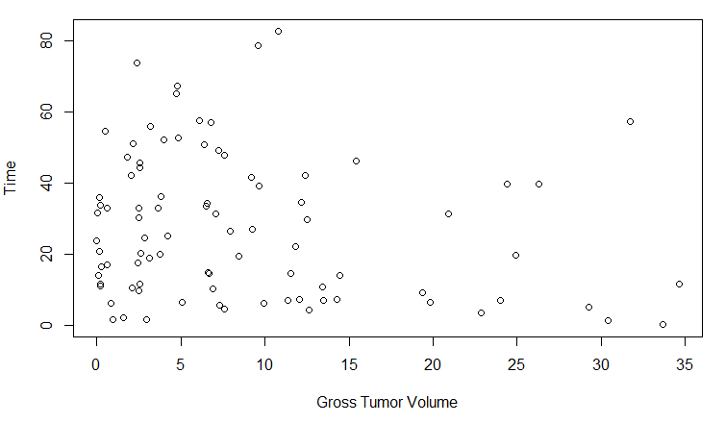

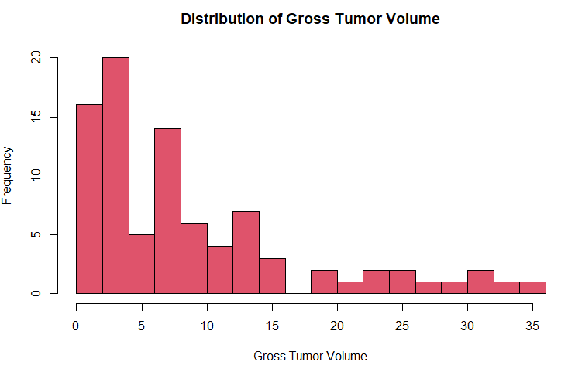

* Data = College

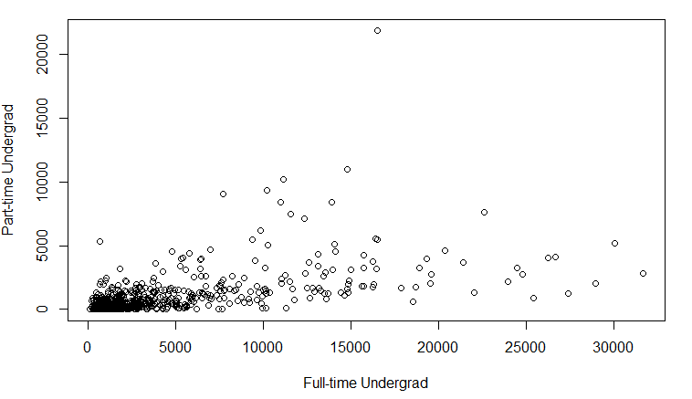

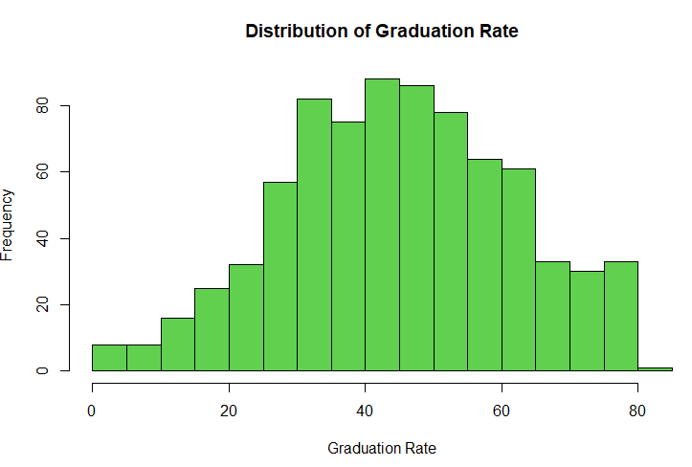

* Data = Credit

